Dear Board of Directors.
From the Science Committee
The science committee is looking to expand our area by about 40 sqft. The reasoning for this is due to the limited class size that can take place in the science area.
We can currently only have about 4 people in the space at any given time comfortably. When we have a class that many people are interested (6 or more) in classes such as the acetone chamber or eggshell course. It makes it very difficult to retain new members and have large teaching sessions.
Beginning at the end of April we will more courses as most of our members will have stopped traveling. I for one will be teaching how to make conductive paint at the end of April which will receive interest from electronics, 3D printing and animatronics. There will also be more chemistry, mushrooms, bioethics introduction and microbiology courses. Which will have interest outside of just our members.
We would like to propose moving our shelves found in the figure below. Such a simple 2 ft move along 18 feet. Will give us nearly 40sqft, providing give us a good amount of space so for walking, talking and teaching in the science area without affecting the flow of Makerspace. It will not block any of the door’s effect nor affect the electronics area.
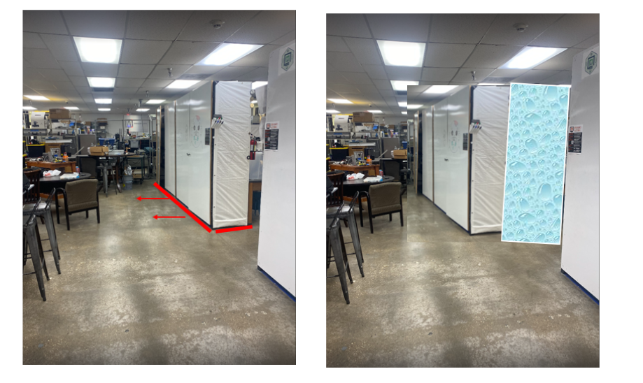
Thank you for you time and consideration.
Figure 1. Movement of Scientific Cabinets. To the front of the old cabinet positions.

